Christie Park Air Photo



Orchid Island, Taiwan to Seattle: Pacific Connections Map

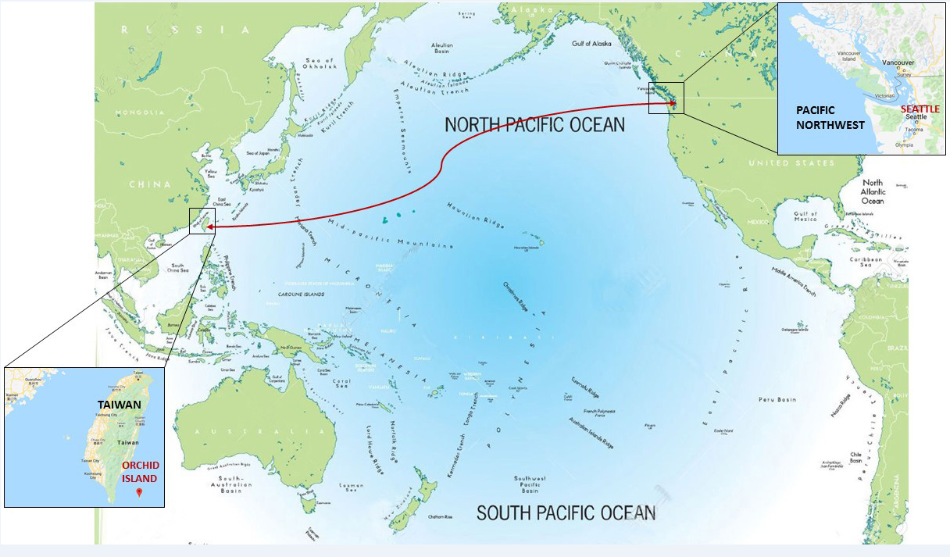

Christie Park Schematic Plan – Art Donation in Northeast Corner

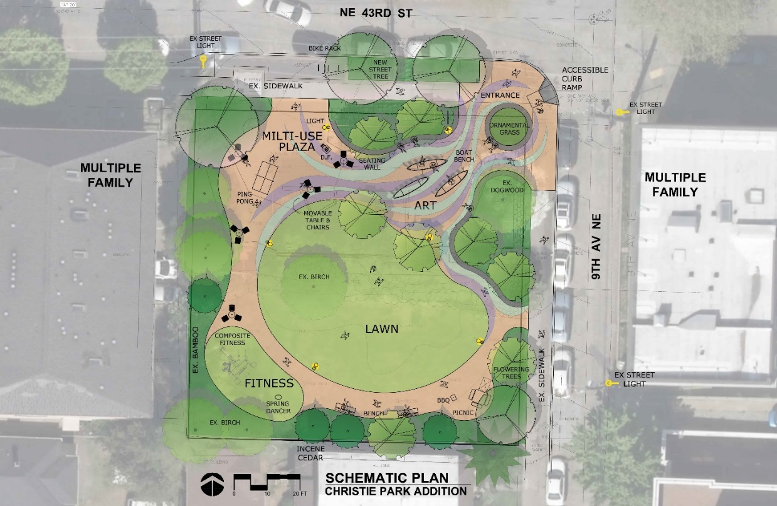

Christie Park Boat Art

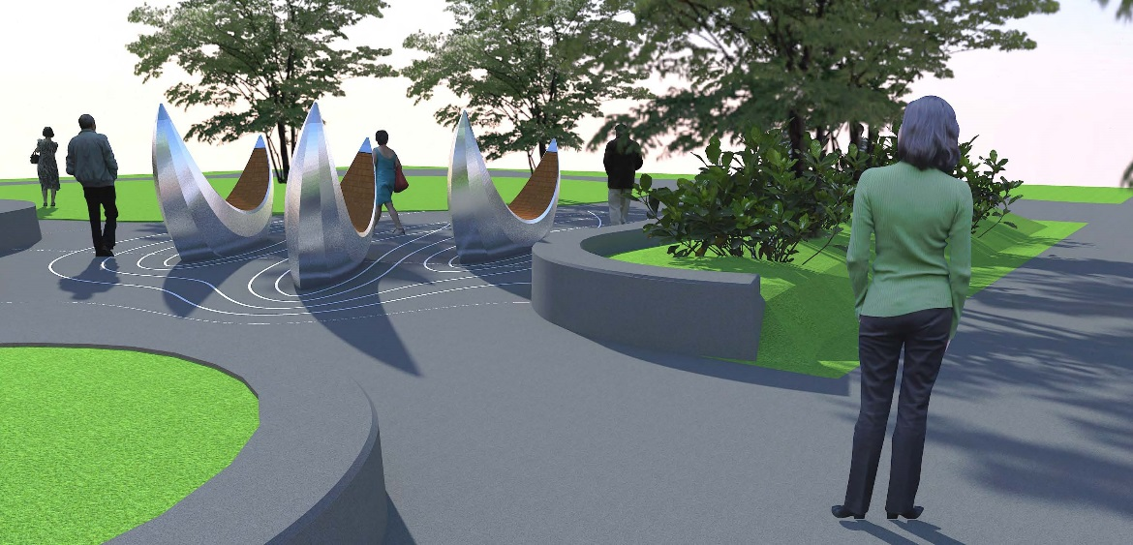

Christie Park Tile Art

